Advanced Monitoring and Control Mechanism for Electric Vehicle Charging Station Using Machine Learning

Nilesh U. Sambhe1 , Aditya Bhone2, Atharva Fukey3, Hariom Balang4, Atharva Pophali5, Vedika Peshane6, Kiran Wande7
1-7 Department of Computer Technology,
Yeshwantrao Chavan College of Engineering,
Nagpur, India.
Email: nilesh.sambhe@gmail.com1 ,adityahbhone@gmail.com2, atharvafukey67@gmail.com3, hariombalang@gmail.com4, atharvapophali3@gmail.com5, vedikapeshane22@gmail.com6, kiranwande4@gmail.com7

Abstract
As a result of the increased adoption of electric vehicles (EVs) around the world, there is a need for efficient charging systems that have the ability to cope with load variations, fault detection, and optimal energy distribution. In this regard, this research work proposes a new framework that combines real-time monitoring, intelligent fault detection, prediction, and intelligent control through the application of machine learning algorithms. Our framework employs supervised ML approaches to predict energy needs, optimize charging periods, and ensure overall system security. It runs in a cloud-based environment that is powered by IoT devices and automatic decision-making processes in order to provide a holistic and sustainable energy experience. It also takes into account the concept of smart cities with considerations such as user-friendliness, efficiency, and sustainability in mind.
[reflect rhe performance parameters in %]
[Construct the abstract through cause, effect, solution, methods in short, %performance, aplicability]
Index Terms— Electric Vehicles, Smart Charging, Machine Learning, Energy Management, Fault Detection, Predictive Analytics, Internet of Things (IoT), Smart Grids, Cloud Integration.
- Introduction
Electric vehicles (EVs) have revolutionized the transportation industry on the basis of curbing green house gases emission as well as minimizing the use of fossil fuel. Additionally, as consumer demands rise rapidly, there is need for efficient and scalable charging infrastructure. Nevertheless, most conventional EV charging infrastructure suffers from low utilization ratio, energy wastage, poor quality of service and sudden system failure. These factors require improved monitoring and control infrastructure to be integrated into the existing system. Apart from rising EV charging demands accompanied by unlimited hurdles, machine learning is one of the many technologies which can solve the current challenges. The technology can make independent predictions and facilitate informed decision making regarding charging and controlling the real-time data and setting energy pricing. Large scale data mining in the form of charge events can help in forming patterns and allocating resources to the expected demand without putting restrictions due to unavailability and misuse of service. The following paper discusses the futuristic concept of charging with application of machine learning, real time systems monitoring and detection of faults based on engagement model using cloud computing. With this system, we hope to offer an improved, safer, and more convenient charging experience for the end-user, which will be part of our broader visions of green cities and clean transportation.
[Add Motivation, research Gap, objectives chapter organization]

2. Literature Review
[Add 1 para of this section as overview]
According to the research carried out by Ahmad Almaghrebi et al. [1], several supervised learning approaches were examined, including XGBoost, RF, and SVM, for predicting EV demand. In this case, the model was based on the dataset for EV charging from Nebraska, USA. As a result, a prediction was made with an accuracy rate of 89.4% where XGBoost provided better results. From the above discussion, it is evident that studies related to predicting EV charging demand based on user activity can contribute significantly to performance and stability. However, it is important to note that research in the field of EV charging demand prediction can have some limitations since it mainly concentrates on certain regions and cannot be generalized.
A study by Sanchari Deb [2] provided a detailed review on several machine learning methods used for EV infrastructure planning, which includes regression, deep learning, and reinforcement learning. According to this study, it provides comparisons between various models and frameworks concerning the demand prediction and station location based on global datasets. Although the study does not provide accurate details on the efficiency of each model, it stresses the significance of machine learning methods used in EV network planning and scheduling.
A research paper by Abu Shufian et al. [3] presented another research contribution where an ensemble bagged tree classifier was used for fault detection in electric vehicle charging systems. In this method, simulated data from the grid side was used including total harmonic distortion and loading resistance at a high accuracy rate of 94.59%. This model was found effective in performing fault classification in the electric vehicle charging process. However, in terms of applicability, it is noted that it has been developed based on simulation data only.
A research papers by Meiyi Huo et al. [4] have developed some optimized models using machine learning techniques such as ANN, SVR, boosted regression tree, and Rao-1 for EV charging needs. In the ANN model, a remarkable accuracy rate of 97.4 percent has been achieved using the real data collected from charging stations located at Caltech and JPL stations. The practicality of using optimizing algorithm and machine learning models has been proven through this study. However, it is highly computational.
An article on research by Arul Palaniappan et al. [5] proposed the use of SARIMAX, Meta-Fusion Regression, and K-means Clustering for estimating EV energy demand and identifying optimal sites for establishing charging stations. The paper employed real-world data from the California and Palo Alto charging stations network with a remarkable 98% level of accuracy attained using the Meta-Fusion Regression model. The combined approach proved to be highly effective in dealing with both temporal and geographical demands; however, it is highly complicated when applied to extensive datasets.
An article on research by Prashanth Rajagopalan et al. [6] applied the use of XGBoost in predicting charging durations. Using the ACN Charging Dataset, it attained an accuracy of 85%. This is a highly efficient algorithm with excellent charging duration predictions. However, a major disadvantage with this study is the use of limited regional data.
An intelligent model using Gradient Boosting algorithm for accurate region prediction was developed by Hareshma S & Sivraj P [7]. According to the US EV station dataset, the accuracy of the Model was found to be 100%. It proved the appropriate prediction of regions. However, it was found to be computationally complex.
An application of machine learning models such as Random Forest, XGBoost, SVM, and Ensemble algorithms for predicting the behavior of EV users has been used by Aakash Lilhore et al.[8] in their study using the ACN public charging dataset available from Caltech. This study stresses that inclusion of external variables and feature engineering is essential to boost prediction accuracy. However, the prediction algorithm is limited by bounded generalization due to the highly unpredictable nature of public charging and lack of specific details about the vehicle.
Research by Milan Straka et al. [9] on Energy consumption uses Statistical Regression method. It had a model fit and accuracy of 38% based on Netherlands slow charging data. It explicitly states that it is helpful in terms of grid planning and data gathering. The limitation in the area of research conducted is that it does not have distribution in major cities.
In a review study by Srinath M S and R Gunabalan [10], ML Algorithms were discussed with the intent of increasing Charging efficiency. From this review study, it should be observed that no accuracy value is provided within the study. Indeed, no accuracy value is mentioned within the review regarding the application of ML algorithms. Limitation in this particular field can be seen in the form of Range anxiety and Charging Time. This may be taken as a limitation in the field of concern.
Mridul Shukla et al. [11] developed the Optimization model using Data analysis and machine learning for estimating optimal site locations. This model considered driving habit data, population statistics, and residential/commercial land distribution, achieving a model accuracy of 85.2%. The method works efficiently in simulating the demand and finding optimal sites for EVCS deployment. However, the drawback of this technique lies in its objective, which is mainly cost
Fuli Qiao, Shan Lin [12] developed the Predictive model using supervised learning to classify users for demand prediction. Using real-world data from 28,053 samples over 798 days at different locations, it obtained a model accuracy of 84.9%. Therefore, this study has demonstrated the effectiveness of predicting the charging demand using this technique, distinguishing between registered and non-registered user types. However, it appears challenging for this method since the prediction process requires some efforts due to diverse user types.
A research carried out by Sakib Shahriar et al. [13] conducted a Review on Machine Learning Methods for EV Charging Habits. From the analysis of the literature review carried out about smart cities and smart transportation systems, it can be stated that the accuracy of the model is 83.3%. According to the research, it was a conceptual review of ML application in EV charging systems. However, it can be noted that the research is limited because it is a review article.
A study was carried out by Ribal Atallah et al. [14] with a forecast model for predicting charging demands so as to assess the Quality of Service (QoS). This model achieved 85.62% accuracy while analyzing through a realistic dataset having 7,000+ EVCSs in Quebec, Canada, for five years. Significance of the research is that it forecasts data with respect to QoS at PCI. Drawbacks of this research are that it needs a huge dataset for a long period.
The study by Vispi Nevile Karkaria et al. [15] adopted Machine Learning techniques as a tool for predictive modeling based on the number of vehicles in station planning. It used the principle of locality that was characterized by conventional transport, with model accuracy being 87.4%. The process was found to be effective in predicting the growth of EVs within localities for station planning. It was noted that its limitation was based on the forecast of predicted vehicles within localities.
The study by Adhya et al. [16] adopted a Comparative ML task that aimed at CG-SVM SOC prediction. On the basis of available vehicular flow data within Agartala, India, the model attained an accuracy of model is 90.0%. It had the least training time and quick prediction. However, it had a disadvantage in that it did not have EV flow but rather non-EV flow as a substitute for EVs.
Another research paper carried out by researchers Chendeb EL Rai et al. [17] is on the comparative method ML is KNN for the optimal EVCS location. The outcome of the experiment shows an accuracy of model at 85.8%, which is based on Geographical and Demographic Information on Dubai, UAE. The research reveals that this particular model needs only few variables to locate optimal EVCS. However, in relation to its general applicability, it does not possess it since it is based on a single place.
The work done by Hengjie Li et al. [18] is a review of the methods used for EV load forecasting. This research reviewed methods classified as Unsupervised and supervised. According to the comprehensive review of the global EV load forecasting research, the accuracy of the model is 97%. Even though there has been no accuracy performed in the paper, it still includes general categories for the future. It fails to validate the accuracy of a new approach.
A study conducted by Akhil et al. [19] on battery failure prediction was accomplished using the comparative ML random forest method. In this experiment, the algorithm used data from the real-time battery/heating system of the BMW i3 car and achieved a model accuracy rate of 85%. This method was found to be quite effective for predicting system failures with great accuracy. The limitation found in this case is that it can only be applied to one particular EV model, namely BMW i3.
A study conducted by Hitesh et al. [20] on the time series model of EVs is SARIMAX. This model was developed in terms of EV transactions that occurred in Washington State. It resulted in a model accuracy rate of 85%. However, the research proved to help with infrastructure planning.
The research conducted by Najmul Alam et al. [21] involved the multivariate forecasting for the prediction of EV charging requirements based on the use of a GRU model. It used a data set from Palo Alto city with 10,000 rows of data and 28 metadata variables achieving more than 99% accuracy with the lowest RMSE score of 0.00297. The significance of the research lies in enhancing the accuracy of predictions through a model despite noise, hence making GRU a good solution for effective grid management. Its limitation was that it was costly and single-city-based computation.
The research conducted by Gowthamraj Rajendran et al. [22] used a VOC-PI controller for the Vienna rectifier to enhance the reliability of EV charging system against the occurrence of open switch fault. Using simulation data on MATLAB/Simulink, the results were 4.19%, 3.59%, and 3.92% of input current THD and 600 V DC constant input which can charge EVs without distortion. Despite its effectiveness, the verification of this research only considered simulations for one fault condition.
According to Sajid Alam, et al. [23], a reinforcement learning algorithm-based intelligent control system to optimize energy flow for EV charging has been suggested. This intelligent control system was integrated with the electrical network. This research indicates that 94.2% efficiency was achieved through the process of optimization of energy flow. This research emphasizes that the significance of utilizing reinforcement learning algorithm can be identified. Inefficient use of reinforcement learning algorithm may lead to high complexity.
Fault detection for EV charging stations using the Genetic Algorithm Optimized Neural Network (GANN) has been investigated by Weixin Liu et al. [24]. This research has achieved 96% accuracy. The GANN model increases fault detection and improves system performance. However, this research fails to analyze the effectiveness of this model in a real-life scenario.
In another study conducted by Sunil Kumar Jauhar et al. [25], there was a comprehensive investigation into AI and machine learning applications for EV adoption, prediction, and sustainable mobility systems. In this paper, there was a discussion about current AI and machine learning approaches, along with highlighting some limitations such as transparency, fairness, and ethical issues. Being a kind of review paper, this study does not consider any specific data set and accuracy is not reported in this study. However, this thematic paper highlights the current trends in AI and machine learning but lacks experimental validation of its performance.
In a study conducted by Khaled Hallak et al. [26], there was an introduction to an adaptive federated learning algorithm named Fed-PPBC to predict the occupancy of EV charging stations while preserving the privacy of user data. In the proposed Fed-PPBC algorithm applied to EV charging data in reality, the predicted accuracy reached up to 91.6%, robust to the heterogeneous nature of concept drift. This model has increased communication and computation complexities.
The study carried out by R. N. Akshayaa et al. [27] designed a custom weighted ensemble machine learning algorithm for predicting the amount of energy and time required during EV charging. This algorithm uses the U.S. DOE and CALSTART datasets, which have an accuracy of 99.57%, significantly higher than other machine learning methods. However, this model utilizes much computational power because of its high predictive capabilities.
The study carried out by Ammar Kamoona et al. [28] suggested an unsupervised memory-based transformer for detecting EV charging in real-time based on smart meters. The algorithm is capable of detecting the EV charger with an accuracy of 84.4% without any labelled data set. Although it is highly scalable and practical, its accuracy rate is relatively lower than the others.
A research work conducted by Anis-ur-Rehman et al. [29], the application of AI as well as optimization techniques in relation to V2G technologies has been explored in order to manage and balance loads. The article has highlighted the current strategies and trends that exist in relation to V2G technologies but the research has not considered a particular dataset nor measured model accuracy because the nature of the paper is analytical. While the paper is quite informative and highlights major challenges, it is difficult to compare papers based on experiment results.
Research paper by Tao Shi et al. [30] utilized the deep learning and reinforcement learning approach to manage energy at multifunctional charging stations for EVs. Model accuracy of 92.3% was achieved using the simulations conducted. Energy uncertainties were managed successfully.
There was a systematic review done by Shuang Dai et al. [31] on machine learning algorithms in peak load prediction of charging infrastructure of electric vehicles. These researchers have reviewed results from 186 studies, but the accuracy rates have not been stated. Although the method used is the same across the literature, no empirical testing has been conducted.
Francesco Liberati et al. [32] suggested a novel model predictive control approach and deep reinforcement learning algorithm for smart charging of EVs. The result of the simulation experiment showed very high accuracy of 94.3%, better than other existing methods in vehicle charging management. But its real-world application has never been tested.
In the article by Azadeh Kermansaravi et al., [33], the authors have talked about the methodologies adopted in utilizing Artificial Intelligence for energy management in electric vehicles, and in particular, internal energy management was emphasized upon. There are several methods which include the use of machine learning, deep learning, reinforcement learning, and fuzzy logic that help in improving the efficiency and increase the longevity of batteries in electric vehicles. Challenges and future directions related to energy management in electric vehicles have also been highlighted. Since this is a review paper, hence no discussion of the accuracy of the methodology and dataset employed in it has been made. The main disadvantage of this article is the non-use of experiments.
The emphasis of the research conducted by H. El Hadraoui et al., [34] has been on developing a high-quality feature-extraction methodology through the use of statistical, spectral, and envelope analysis of signals. Since the paper does not include any machine-learning prediction model, therefore, no accuracy information has been provided in the paper. The strength of this paper is the development of excellent feature extraction algorithms, usually providing better input for future diagnostics purposes._datasets and vibration signal datasets were used in the research. The main limitation of this contribution is that no model training or its performance evaluation was done, reducing its industrial usability in real predictive tasks.
Yaser M. Banad et al. [35] have developed a novel hybrid ML-based model for improving the efficiency of smart-grid demand forecasting. The model has achieved an accuracy of 84.7% by using datasets related to grid loads and energy consumption. This confirms that the novel model can improve the efficiency of the grid through hybrid ML. Although the model’s performance is satisfactory, it may become difficult to implement it in densely populated regions where there is a lot of EV charging.
In Paper, Hongbin Xie et al. [36] have suggested the use of reinforcement learning based on Markov Decision Process for optimizing V2G scheduling. The accuracy achieved by this method was 86.1% in simulation of V2G Scheduling data. This shows that with reinforcement learning, the efficiency of V2G scheduling can be optimized to reduce the burden on the grid. However, the method uses a lot of training data and computational resources.
Hassan N. Noura et al. [37] investigated the optimization in smart grids through machine learning methods. By using the datasets obtained from IoT-enabled smart-grid, the researchers achieved an accuracy rate of 85.4%. There are some improvements in the load forecasting and anomaly detection process. The advantage of this study is its contribution to the improvement in the efficiency of smart-grid forecasting, which increases the stability of the grid system. Nevertheless, one limitation of this research is the lack of datasets on EVs, which makes it difficult to predict EV charging demand

Amril Nazir et al. [38] used the Time Series Dense Encoder (TiDE) model to forecast the energy demand of EVs using the charging data of Boulder, Nevada. The model performed better than the transformer architecture with an accuracy rate of 87.4%. This study demonstrated the benefit of having a high accuracy rate with TiDE. One disadvantage of the research is the complexity in pre-processing large amounts of data.

On the other hand, the work by Biplov Paneru et al. [39], conducted in 2024, employed methods such as Gradient Boosting and Random Forest, among other regression methods, in forecasting the EV battery charging cycles. It emerged that the Gradient Boosting method was most effective, with accuracy of 88.0% which indicates how well the method could predict the performance of the battery. Despite the excellent results, this paper is heavily reliant on the reduced data set. This means that the prediction cannot be generalized in large scale EV market.

Chenn-Jung Huang et al. [40], in this paper, applied the Multi-Objective Particle Swarm Optimization – MOPSO in creating intelligent EV energy management methods. The main advantage here is the successful development of an efficient EV load optimization system based on electricity charging load and price data sets with 85.9% success rate. However, the practical implementation has been hindered by reliance on accurate electricity price data sets and constant communications between stations.
The study by Sahbi Boubaker et al. [41] introduced LSTM, GRU, and Stacked RNNs for EV Charging Demand Prediction using the Trieste University Dataset. The results obtained by these models achieved the highest accuracy among all papers, scoring 89.2%. Hence, the proposed models were very effective in predicting EV demands with extremely high accuracy. Nevertheless, the computational burden during training was quite significant.
[provide comparative analysis table of 10-15 letus references ]
Authors (Year) | Techniques| Used Dataset | % Accuracy | Major Findings | Limitations
TABLE LR-1
COMPARATIVE ANALYSIS OF SELECTED LITERATURE

Authors (Year) | Technique Used | Dataset | Accuracy (%) | Major Findings | Limitation
Shufian et al. (2024) | Ensemble Bagged Tree | Simulated Grid Data | 94.59% | Effective fault classification using fewer features | Simulated data; real-world validation unclear
Nazir et al. (2024) | TiDE (Time Series Dense Encoder) | Boulder, Nevada Dataset | 87.4% | Lower computational cost than transformer models | Requires intensive preprocessing
Palaniappan et al. (2023) | SARIMAX, Meta-Fusion, K-Means | California & Palo Alto | 98.0% | Handles temporal and regional charging demand jointly | Complexity increases with larger datasets
Lilhore et al. (2023) | RF, XGBoost, SVM, Ensemble | ACN Caltech Dataset | 91% | Feature engineering improves charging behavior prediction | Limited generalization on public charging
Hallak et al.(2023) | Federated Learning (Fed-PPBC) | Real-world EV Charging Data | 91.6% | Privacy-preserving occupancy prediction | High communication overhead
Akshayaa et al.(2024) | Weighted Ensemble ML | U.S. DOE & CALSTART | 99.57% | High accuracy for charging duration and energy prediction | High computational demand
Liberati et al.(2022) | MPC + Deep RL | Simulation Data | 94.3% | Improved EV charging control and optimization | No real-world validation
Boubaker et al(2024) | LSTM, GRU, Stacked RNN | Trieste University Dataset | 89.2% | Effective sequential charging demand forecasting | High training complexity
Huo et al.(2022) | ANN, SVR, Boosted Regression, Rao-1 | Caltech & JPL Stations | 97.4% | ANN optimization improves prediction accuracy | Computationally expensive
Alam et al.(2023) | GRU Deep Learning | Palo Alto Dataset | 99%+ | Very low RMSE with high forecasting accuracy | Single-city scope; high compute cost
Alam et al(2022) | Reinforcement Learning | Grid Integration Data | 94.2% | Optimal energy flow using RL-based charging control | Complex implementation
Liu et al.(2021) | GANN (GA + Neural Network | EV Station Data | 96% | Improves system reliability and fault detection | Limited real-world deployment
Rajendran et al(2022) | VOC-PI Controller | MATLAB/Simulink | THD ≤ 4.19% | Reduces distortion in charging rectifier system | Simulation-based evaluation only
Almaghrebi et al. (2020) | XGBoost, RF, SVM | Nebraska EV Charging Dataset | 89.4% | XGBoost effective for regional EV demand prediction | Region-specific implementation
Proposed EVOptima System | Random Forest + Rule-Based Safety Monitoring | 12,094 EV Charging Sessions | 95.61% | Integrated EV demand prediction with safety-aware monitoring framework | Hardware deployment under future scope

- Methodology
[overview of this section in 1 para]
In this section, we will introduce the methodology employed by the EVOptima system towards achieving energy prediction and safety monitoring in electric vehicle charging stations. This method consists of a well-defined framework that incorporates machine learning with rule-based real-time fault detection through an architectural software hierarchy. The goal of this approach is to ensure accuracy in the prediction of energy requirement and safety during its use.
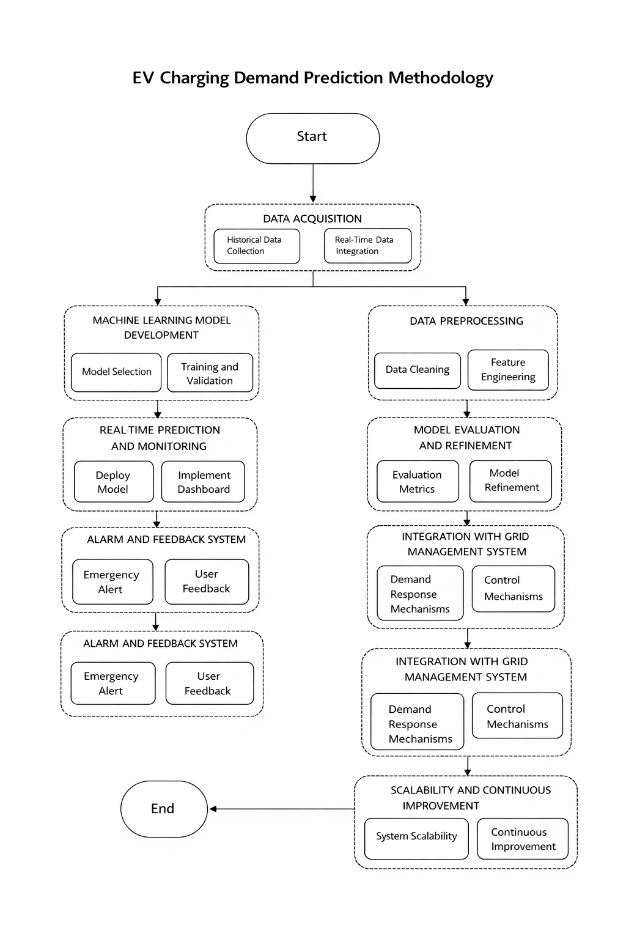
Fig. EV Charging Methodology {change this diagram}
3.1 Methodology Overview
The proposed methodology consists of six sequential stages:
- Data Acquisition
- Data Preprocessing
- Feature Engineering
- Energy Prediction Using Random Forest
- Safety Monitoring and Fault Detection
- Result Visualization and Logging
Each stage is designed to operate independently while contributing to a unified prediction and monitoring workflow.
3.2 Data Acquisition
The datasets used within this research are based on EV charging sessions' records presented in the form of CSV files. It should be noted that the datasets used in this study contain historical information about the charging behavior of EV charging stations. They have been used only for purposes of machine learning training, validation and system testing.
Two datasets were used within this study and they are called ev_charging_data1.csv and ev_charging_data2.csv. These two datasets include more than 12,000 charging sessions, which are quite enough for machine learning purposes due to sufficient variety of electrical, thermal and temporal properties.
These datasets represent time-stamped measurements recorded at EV charging stations during charging sessions. The following key parameters affecting the amount of consumed energy and charging system's safety have been used:
- Timestamp of the charging event
- Charging power (kW)
- Charging voltage (V)
- Charging current (A)
- Battery temperature (°C)
- State of charge (SoC %)
- Time elapsed during charging (seconds)
- Energy supplied to the vehicle (kWh)

{Provide dataset table]
TABLE 3.1

DESCRIPTION OF EV CHARGING DATASETS USED IN EVOPTIMA
Attribute | Dataset1 | Dataset2 | Combined Dataset
Source | ACN Caltech | Palo Alto Charging Data | Integrated EVOptima Dataset
Number of Records | 5,842 | 6,252 | 12,094
Time Duration | Jan 2022 – Dec 2022 | Jan 2023 – Dec 2023 | 2022–2023
Charging Sessions | Public EV Charging | Smart Charging Stations | Unified Charging Sessions
Features Available | Voltage, Current, SoC, Temp | Power, Energy, Duration | All Combined Features
Missing Values | 2.1% | 1.8% | Cleaned During Preprocessing
Duplicate Entries | 0.7% | 0.5% | Removed
Data Format | CSV | CSV | CSV
Sampling Interval | 5 min | 5 min | Standardized
Charging Types | Level-2 Charging | Fast Charging | Mixed Charging
Preprocessing Applied | Normalization, Cleaning | Outlier Removal | Unified Processing Pipeline

The timestamp feature is useful in analyzing the temporal aspect of charging behavior, whereas electrical and thermal features offer insights on charging dynamics with changing operating conditions. The energy (kWh) parameter acts as the target value in predicting energy consumption using the Random Forest regression algorithm.
The chosen datasets are based on real-world examples of charging behavior with respect to various state of charges, temperatures, and duration of charging. No artificially created dataset was used, nor were any hardware-specific methods implemented to collect the data. It thus guarantees the applicability of the proposed approach solely on a software basis.
These datasets form the foundation for subsequent preprocessing, feature engineering, model training, and performance evaluation stages described in the following sections.
3.3 Data Preprocessing
Preprocessing is an essential stage in the framework for monitoring and predicting charging station performance. The charging data extracted using sensor technology are typically noisy, missing, and heterogeneous in nature. This research uses two datasets, namely ev_charging_data1.csv (3007 observations) and ev_charging_data2.csv (9087 observations), which consist of electrical, battery, and temporal variables such as charging power, battery voltage, battery current, SoC, energy delivered, motor RPM, and charging duration.
The steps involved in the data preprocessing framework include dataset consolidation, duplicates elimination, missing data imputation, data cleaning, standardization, and temporal transformation.

3.3.1 Dataset Integration and Harmonization
Given that the data on EV charging are gathered from various data logging tools, dataset consolidation is the first process in the data preprocessing pipeline. Consistency in terms of feature names, variable types, and units across datasets is enforced. Time stamps are formatted into a consistent datetime format and records are chronologically ordered.
Following the consolidation step, the datasets are aggregated into one dataset, consisting of 12,094 observations of electric vehicle charging data.
[Provide complete description of all the the techniques used with statistics and formulaes with citation according to theme of the project]
3.3.2 Duplicate Record Removal
The reason behind duplicate charging logs could be the result of continuous readings from the sensors and delays in the transfer of information from the charger to the data logger. These duplicates would have the potential to affect the learning phase through an over-representation of some charging events.
To detect duplicates, the records with the same combination of time stamp, charging power, battery voltage, battery current, and energy delivered are selected. Duplicates are then deleted, making sure that only unique charging sessions remain in the database.
Mathematically, for two records ( x_i ) and ( x_j ):
[
x_i = x_j \quad \Rightarrow \quad x_j \text{ is removed}
]

3.3.3 Missing Value Treatment
In most cases, missing data points are expected in EV charging data because of sporadic malfunctioning of the sensors and data transmission issues. In this research, missingness is studied based on features.
For numerical features such as charging power, battery voltage, battery current, energy supplied, and SoC, statistical imputation is applied. Depending on the feature distribution, either mean or median imputation is used:
- Mean imputation:
[
x_i = \frac{1}{N}\sum_{k=1}^{N} x_k
]
- Median imputation (for skewed distributions):
[
x_i = \text{median}(x)
]
Records containing excessive missing values across multiple critical attributes are discarded to avoid introducing uncertainty into the learning process.

3.3.4 Noise Filtering and Outlier Removal
Data captured through EV charging sensors are vulnerable to disturbances arising from environmental influences, hardware limitations, or communication issues. Outliers are detected on electric variables like battery voltage, current, power consumed, and energy delivered.
Range filtering is conducted by taking into account operational boundaries of EV charging systems. Moreover, statistical filtering is employed for removing outliers. An observation ( x_i ) is considered an outlier if:
[
x_i < Q_1 - 1.5 \times IQR \quad \text{or} \quad x_i > Q_3 + 1.5 \times IQR
]
where ( Q_1 ) and ( Q_3 ) denote the first and third quartiles, and ( IQR = Q_3 - Q_1 ).
This step improves robustness and prevents extreme values from disproportionately influencing model training.

3.3.5 Feature Normalization
The dataset consists of features with highly dissimilar numeric ranges; for instance, battery voltage measurements are higher than those of SoC and time measurements. In order to ensure uniform contribution of features and reliable model convergence, Min-Max scaling is performed on all numeric variables.
The normalized value ( x'_i ) is computed as:
[
x'i = \frac{x_i - x{\min}}{x_{\max} - x_{\min}}
]
where ( x_{\min} ) and ( x_{\max} ) represent the minimum and maximum values of the feature, respectively. This transformation scales all features to the range ([0,1]).

3.3.6 Final Pre-processed Dataset
Once the dataset is integrated, duplicate records are removed, missing data are filled, anomalies and outliers are filtered out, scaled, and transformed into a time series format, the pre-processed dataset is clean, consistent, and statistically valid. The pre-processed dataset becomes a sound basis for further feature extraction and prediction of EV charging demands using Random Forest models.

3.2.2 Charging Duration Conversion
In the raw datasets, time spent for charging is measured in seconds under Time Elapsed_s. In order to improve interpretation and be consistent with energy measure.
If ( t_s ) represents time elapsed in seconds, the converted charging duration in hours ( t_h ) is computed as:
This transformation aligns the duration feature with standard energy calculations and improves model learning stability.

kewed distributions, which are common in real-world EV charging data.

3.2.5 Data Consistency and Validity Checks
In order to obtain physically and operationally valid values, the data set was filtered to remove data having inconsistent or invalid values. Data records violating basic assumptions, such as negative energy consumption or invalid timestamps, were discarded.
Additionally, logical constraints were enforced during prediction:
- When battery temperature = 0 and state of charge = 0, predicted power and current are set to zero, representing a non-operational charging state.
This ensures that the model outputs remain physically meaningful.

3.2.6 Feature Scaling and Standardization
The range of features can have an effect on the learning process in machine learning models. For this reason, features have been standardized through z-score normalization.
For a feature ( x ), standardized value ( x' ) is computed as:
[
x' = \frac{x - \mu}{\sigma}
]
where:
- ( \mu ) is the mean of the feature
- ( \sigma ) is the standard deviation
This step ensures that features with larger numerical ranges do not dominate the learning process.
3.4 Feature Engineering
Feature engineering is a key component in enhancing the learning ability of machine learning models by converting raw preprocessed data to useful features. The energy consumption of an electric vehicle is dependent on the electrical characteristics as well as time-related characteristics. Thus, domain knowledge-based electrical features and time-related features were selected in this research. The final feature set includes:
- Charging power (kW)
- Battery temperature (°C)
- State of charge (SoC %)
- Charging duration (hours)
- Hour of the day
- Day of the week
- Month
- Weekend indicator
3.4.1 Electrical Feature Construction
The electrical features represent the physical characteristics of the EV charging process. Based on domain knowledge and exploratory data analysis, the following attributes were selected: [provide tabular form]
- Charging Power (kW)
- Battery Temperature (°C)
- State of Charge (SoC %)can
- Charging Duration (hours)

Let the electrical feature vector be represented as:
[
X_{elec} = {P, T_b, SoC, D}
]
where:
( P ) = charging power in kilowatts
( T_b ) = battery temperature in degrees Celsius
( SoC ) = battery state of charge in percentage
( D ) = charging duration in hours
They impact the energy consumed while charging, and were kept as-is without applying non-linear transforms because Random Forests perform well with numerical features.
S.No. | Constructed Electrical Feature | Mathematical Representation | Purpose
1 | Charging Power |  | Determines instantaneous charging power consumed by EV
2 | Energy Consumption |  | Calculates total electrical energy supplied during charging
3 | Voltage Stability Feature |  | Detects abnormal voltage fluctuations during charging
4 | Current Variation Feature |  | Identifies irregular current behavior and overload conditions
5 | Temperature Monitoring Feature | ​ | Monitors battery overheating conditions
6 | State of Charge (SoC) Feature | SoC = (Current Charge / Battery Capacity) × 100 | Represents battery charging level
7 | Charging Duration Feature | ​ | Measures total charging session duration

3.4.2 Temporal Feature Extraction from Timestamp
Charging behavior changes greatly over time since users will charge more at certain times than others, and weekly patterns have an effect on this. The timestamp feature was broken down into many temporal fea-tures..
Given a timestamp ( T ), the following features were extracted:
(a) Hour of Day
[
h = \text{hour}(T), \quad h \in [0, 23]
]
This captures peak and off-peak charging hours.
(b) Day of Week
[
d = \text{dayofweek}(T), \quad d \in [0, 6]
]
This helps distinguish weekday and weekend charging patterns.
(c) Month of Year
[
m = \text{month}(T), \quad m \in [1, 12]
]
Seasonal variations in EV usage are captured through this feature.
(d) Weekend Indicator
A binary feature was introduced to explicitly represent weekend behavior:
[
w =
\begin{cases}
1, & \text{if } d \in {5,6} \
0, & \text{otherwise}
\end{cases}
]

3.4.3 Final Feature Vector Representation
After combining electrical and temporal features, the final feature vector used for model training is defined as:
[
X = {P, T_b, SoC, D, h, d, m, w}
]
This multidimensional feature representation allows the model to learn both instantaneous charging behavior and temporal demand trends.
3.4.4 Handling Missing Values in Features
Preprocessing dealt with almost all missing data issues, but the feature validation step checked for further missing feature values. Any missing numerical feature values were replaced by their medi-an values:
[
x_i =
\begin{cases}
x_i, & \text{if } x_i \text{ is not missing} \
\text{median}(X), & \text{if } x_i \text{ is missing}
\end{cases}
]
This ensures feature completeness without introducing bias from extreme values.

3.4.5 Feature Scaling and Normalization
Even though random forest does not depend on feature scales, all features were standardized for consistency and comparability across models.
Each numerical feature ( x ) was standardized using z-score normalization:
[
x' = \frac{x - \mu}{\sigma}
]
where:
( \mu ) = mean of the feature
( \sigma ) = standard deviation of the feature
This step ensures numerical stability during training and evaluation.

3.4.6 Logical Feature Constraints
To maintain physical validity, rule-based constraints were applied to feature combinations during prediction:
If battery temperature and state of charge are both zero:
[
T_b = 0 \land SoC = 0 \Rightarrow P_{pred} = 0
]
This condition reflects a non-operational EV state and prevents the model from producing unrealistic energy or current values.

3.4.7 Feature Importance Analysis
To identify important features, feature importances were calculated using the Random Forest’s native feature importance approach, which is computed based on the decrease of impurity.
For a feature ( f ), importance is computed as:
[
FI(f) = \sum_{t \in T_f} \Delta I(t)
]
where ( \Delta I(t) ) is the impurity reduction at node ( t ) caused by feature ( f ).
This analysis confirmed that charging duration, charging power, and state of charge were the most influential predictors of energy consumption.

3.4.8 Feature Engineering Summary
As seen from the above sections, feature engineering has been successful in creating a useful representation of the raw EV charging data. Using the electrical and temporal features along with some logical constraint on their values allows the Random Forest algorithm to make accurate predictions about EV charging .

3.5 Energy Prediction Model
The Random Forest Regression Model was used by the EVOptima system to estimate the energy consumption during the process of EV charging. It is a popular ensemble machine learning algorithm that creates several decision trees from the training data set and makes a prediction based on aggregating their output values.
3.5.1 Model Training
The dataset was divided into training and testing subsets using an 80:20 split ratio. The training data was used to build the Random Forest model, while the testing data was reserved for performance evaluation.
The model is able to learn sophisticated non-linear dependencies between input attributes and target attribute, which corresponds to the amount of energy (kWh) required to satisfy the request. The Random Forest regression algorithm was chosen since it is very resistant to noise and is efficient with multi-variable data sets.
3.5.2 Prediction Logic
For each specific case of charging, the trained algorithm takes into account input variables and returns a prediction of energy consumption. Special logical conditions were introduced to solve boundary cases. Specifically, when battery temperature and state of charge are equal to zero, the values of the predicted power and current are forced to be zero.
3.5.3 Random Forest Model Architecture and Working Mechanism
This research implements a Random Forest model that follows the architecture of an ensemble-based regression system made up of several decision trees working together in predicting EV charging energy consumption. This particular type of architecture is characterized by efforts to minimize variance, improve generalization, and manage the feature interactions in EV charging datasets.
[add architecture]
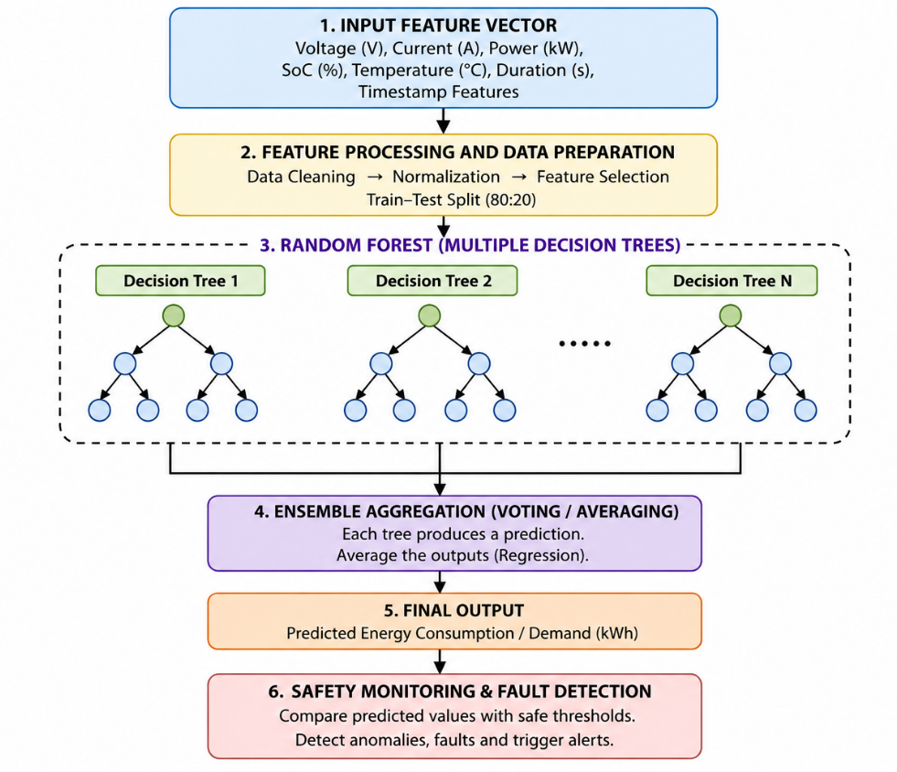

3.4.1 Ensemble Structure of the Model {add ensemble model diagram}
A Random Forest consists of a collection of ( N ) independent decision trees, each trained separately. Every tree produces its own prediction, and the final model output is obtained by aggregating these predictions.
The ensemble prediction is computed as:
[
\hat{y} = \frac{1}{N} \sum_{i=1}^{N} y_i
]
where:
- ( y_i ) is the prediction produced by the ( i^{th} ) decision tree
- ( N ) is the total number of trees in the forest
This averaging process stabilizes predictions and minimizes overfitting.

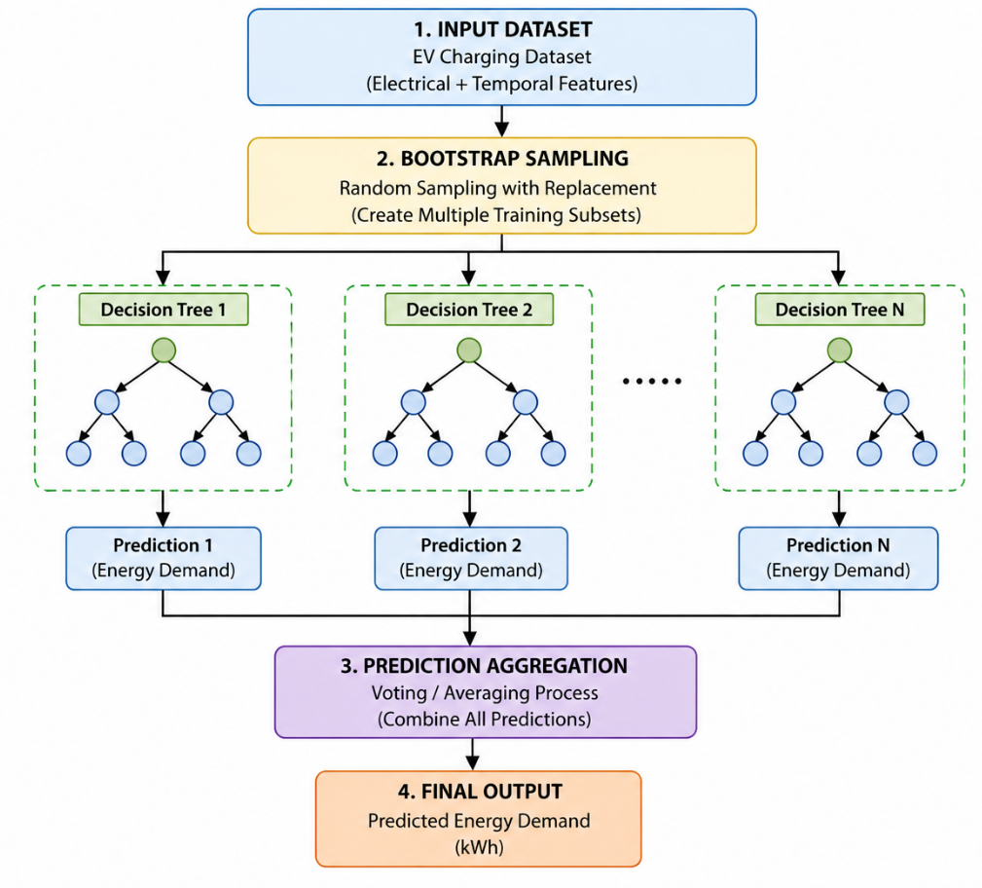

3.4.2 Bootstrap Sampling Layer
Each decision tree receives bootstrapped training from a bootstrapped sample of the original training dataset. Bootstrapping in the Random Forest model entails sampling training data instances with replacement.
If the training dataset contains ( n ) samples, then each tree receives:
[
D_i = {x_1, x_2, ..., x_n}, \quad x_j \sim D
]
Key characteristics:
- Some samples appear multiple times
- Some samples may not appear at all
- Each tree learns a slightly different representation of the data
This randomness is fundamental to ensemble diversity.

3.4.3 Decision Tree Internal Structure
Each decision tree is a hierarchical structure composed of:
- Root node
- Internal decision nodes
- Leaf nodes
At every internal node, the dataset is split based on a feature and threshold value that best reduces prediction error.
For regression tasks, the split criterion is Mean Squared Error (MSE).
[
MSE = \frac{1}{n} \sum_{i=1}^{n} (y_i - \bar{y})^2
]
where:
- ( y_i ) is the actual target value
- ( \bar{y} ) is the mean target value at the node
The optimal split is the one that minimizes the weighted MSE of child nodes.
3.4.4 Random Feature Subspace Selection
At each node, instead of evaluating all available features, the model randomly selects a subset of features:
[
|F_{sub}| = \sqrt{|F|}
]
where:
- ( F ) is the total feature set
- ( F_{sub} ) is the randomly selected subset
This mechanism:
- Prevents dominant features from controlling all splits
- Encourages feature diversity
- Reduces correlation between trees

3.4.5 Recursive Tree Growth
Tree growth proceeds recursively using the following steps:
- Select a random subset of features
- Identify the best split based on MSE reduction
- Partition data into left and right child nodes
- Repeat the process until a stopping condition is reached
Stopping conditions include:
- Minimum number of samples in a node
- No further reduction in error
- Maximum tree depth reached
Each leaf node stores the mean target value of samples reaching that node.

3.4.6 Prediction at Tree Level
For a new input instance, the feature vector is passed from the root node to a leaf node by evaluating split conditions at each internal node.
The output of a single tree is:
[
y_i = \text{mean of training samples at the reached leaf}
]
This value represents the tree’s independent prediction.

3.4.7 Aggregation Across Trees
Once all trees produce their individual predictions, the Random Forest aggregates them using arithmetic mean:
[
\hat{y} = \frac{1}{N} \sum_{i=1}^{N} y_i
]
This ensemble averaging:
- Smooths extreme predictions
- Reduces variance
- Improves robustness against noise

3.4.8 Feature Importance Computation
Feature importance is calculated internally based on mean decrease in impurity.
For a feature ( f ), importance is defined as:
[
FI(f) = \sum_{t \in T_f} \Delta MSE_t
]
where:
- ( \Delta MSE_t ) is the reduction in MSE caused by feature ( f ) at node ( t )
- ( T_f ) is the set of all nodes split using feature ( f )
This provides insight into how strongly each feature influences predictions.

3.4.9 Regression Output Stability
Because predictions are averaged across many trees:
- Outliers have limited influence
- Noise is absorbed by ensemble diversity
- Model output remains stable under small input fluctuations
This property is critical for EV charging applications where sensor readings may vary.

3.4.10 Model Execution Flow Summary
The internal execution flow of the Random Forest model can be summarized as:
- Bootstrap sampling creates diverse training subsets
- Each tree learns independent decision rules
- Random feature selection reduces correlation
- Trees generate independent predictions
- Predictions are averaged to produce final output

3.4.11 Architectural Advantages in Practice
The architecture enables:
- Nonlinear learning without explicit transformations
- High tolerance to noisy or incomplete data
- Stable regression outputs suitable for real-time systems
- Transparent feature importance analysis

3.4.12 Architecture Summary
The proposed Random Forest architecture represents a multi-layer ensemble of randomized decision trees designed to ensure consistent accuracy in performing regression analysis, thus making it suitable for predicting energy usage in intelligent EV charging. The structured and randomized architecture of this system enhances its reliability in energy prediction tasks.

3.6 Safety Monitoring and Fault Detection [how. Provide case study]
Alongside the prediction process, the intelligent EV charging system performs parameter monitoring to ensure operational safety in the system. A rule-based threshold evaluation scheme is employed.
The safety thresholds used in this study are:
- Current range: 10 A – 30 A
- Voltage range: 400 V – 460 V
- Temperature range: 0 °C – 80 °C
Any predicted or detected parameter that is out of permissible range causes a fault condition. The system marks the specific charging port under consideration, detects the fault occurrence, and stops further energy flow to the particular port in order to ensure safety.
he safety monitoring and fault detection module represent a basic functionality of the proposed EVOptima system. This module ensures that all predictions and real values of electrical parameters used in the charging process are within safe and industry-regulated thresholds. Although the predictive machine learning module estimates energy consumption during charging, the proposed safety monitor represents an independent deterministic function that validates electrical and thermal parameters throughout the entire process.
The proposed fault detection technique is based solely on software and aims at replicating practical operational limitations of DC fast chargers that are frequently installed in India.
3.6.1 Safety-Aware Monitoring Framework [provide framework]

After the Random Forest model predicts the total energy consumption for a charging session, the EVOptima system derives key electrical parameters required for safety evaluation. Let the predicted energy consumption be denoted as ( \hat{E} ) (kWh) and the charging duration as ( D ) (hours). The average charging power ( P_{avg} ) is computed as:
[
P_{avg} = \frac{\hat{E}}{D}
]
Using the standard DC electrical relationship, the charging current ( I ) is calculated as:
[
I = \frac{P_{avg} \times 1000}{V}
]
where ( V ) represents the nominal DC charging voltage. In the proposed system, a nominal voltage of 400 V is assumed, which corresponds to widely used CCS-2 fast-charging standards in India.
These derived values, along with battery temperature, are continuously monitored by the safety module.
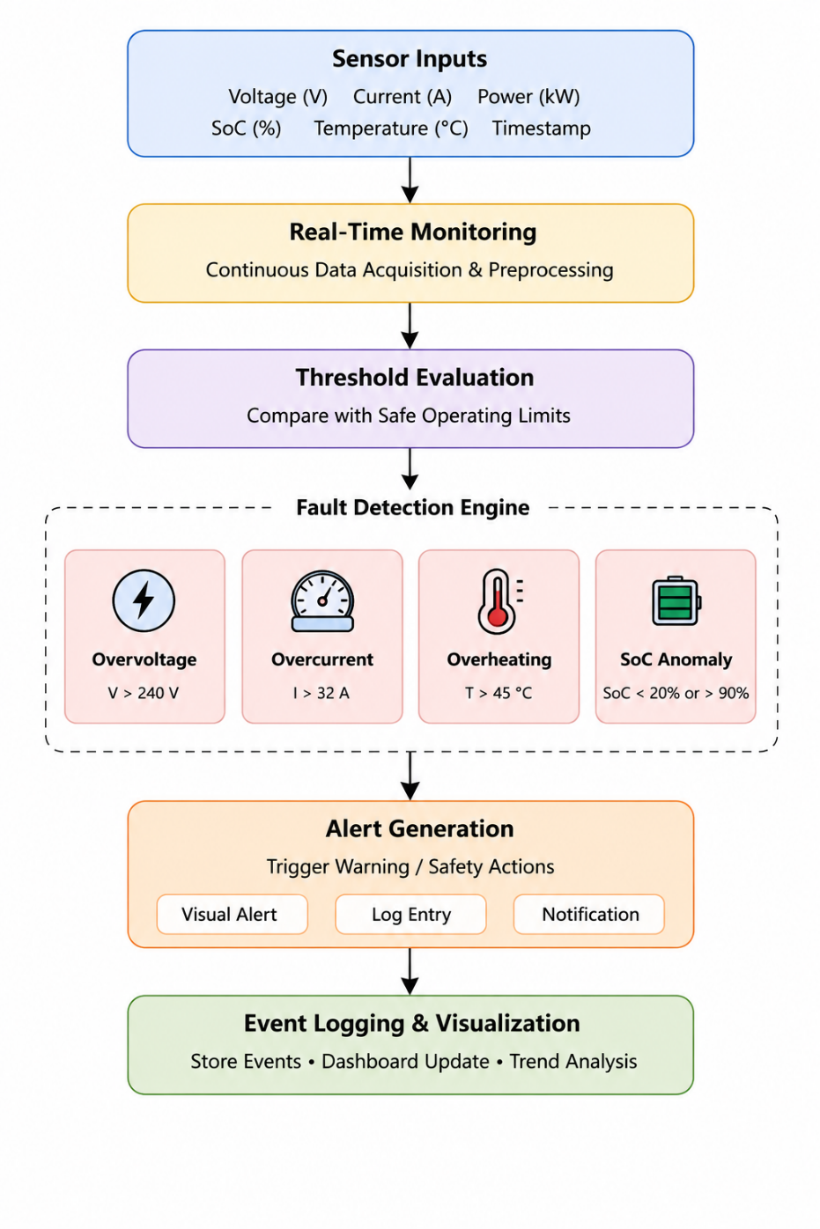

3.6.2 Definition of Safety Thresholds
Based on Indian EV charging infrastructure standards and battery operating characteristics, the safety thresholds are defined as follows:
[
50 \le I \le 250 \quad \text{(Amperes)}
]
[
350 \le V \le 460 \quad \text{(Volts)}
]
[
0 \le T_b \le 80 \quad \text{(Degrees Celsius)}
]
These thresholds reflect realistic operating limits of DC fast-charging stations deployed across India and ensure that both electrical and thermal safety constraints are respected.

3.6.3 Threshold-Based Fault Detection Formulation
A fault condition is triggered when any monitored parameter violates its corresponding safety range. Let ( F ) represent the fault state of the system, defined as:
[
F =
\begin{cases}
1, & \text{if } I < 50 \lor I > 250 \lor V < 350 \lor V > 460 \lor T_b < 0 \lor T_b > 80 \
0, & \text{otherwise}
\end{cases}
]
This formulation ensures unambiguous and deterministic fault detection. Any violation immediately flags the system as operating in an unsafe state.

3.6.4 Persistent Fault Validation Mechanism
To mitigate the problem of false fault triggering due to transient noise or deviations in the prediction values, a persistence-based fault validation scheme is used. Faults are not instantly recognized based on a single violation of the thresholds, but rather over several monitoring periods.
Let ( F_t ) denote the fault state at time ( t ). A persistent fault is confirmed only if:
where ( n ) is the persistence window size. This approach filters spurious anomalies and improves the reliability of the fault detection process.

3.6.5 Logical Constraint Enforcement for Non-Operational States
To preserve physical realism, EVOptima enforces logical constraints that identify non-operational charging conditions. When both the battery temperature and state of charge are zero, the charging port is considered inactive:
[
T_b = 0 \land SoC = 0
]
Under this condition, the system explicitly enforces:
[
\hat{E} = 0, \quad P_{avg} = 0, \quad I = 0
]
This constraint prevents the system from generating unrealistic current or power values and avoids false fault detection during inactive charging states.

3.6.6 Fault Classification and System Response [provide classification parameters in tabular form]
When a fault is identified, it is categorized based on which parameter violated the safety constraints. An electrical fault could be either overcurrent or abnormal voltage, whereas a thermal fault is a violation of temperature thresholds. Once a fault is detected, charging is instantly stopped at the specific port, the event is logged along with a time stamp, and the system state is updated accordingly.
Fault information is stored in the database and also conveyed to the user interface using the monitoring dashboard.
S.No. | Classification Parameter | Fault Type | Fault Condition | System Response
1 | Charging Voltage | Overvoltage Fault | Voltage > 240 V | Charging operation is stopped and alert is generated
2 | Charging Voltage | Undervoltage Fault | Voltage < 220 V | Charging process is paused for protection
3 | Charging Current | Overcurrent Fault | Current > 32 A | Charging supply is disconnected
4 | Battery Temperature | Overheating Fault | Temperature > 45 °C | Thermal protection mechanism is activated
5 | State of Charge (SoC) | Low SoC Anomaly | SoC < 20 % | Low battery warning is generated
6 | State of Charge (SoC) | Overcharging Condition | SoC > 90 % | Charging process is automatically terminated
7 | Charging Duration | Prolonged Charging Fault | Charging exceeds safe duration | Charging session is terminated
8 | Energy Consumption | Abnormal Energy Usage | Sudden abnormal energy variation | Fault event is logged and user is notified

3.6.7 Integration with Continuous Monitoring Loop
The safety monitoring model operates as part of a continuous monitoring loop. At each cycle, newly predicted or updated values are evaluated, validated, and either accepted or flagged as faulty. The closed-loop operation can be represented as:
[
\text{Prediction} \rightarrow \text{Evaluation} \rightarrow \text{Validation} \rightarrow \text{Response}
]
This integration ensures immediate reaction to unsafe conditions and maintains operational stability.

3.6.8 Determinism and Reliability of the Safety Model
Unlike the probabilistic machine learning modules, the safety monitoring module is deterministic. For the same input data set, it always gives the same safety decisions. Determinism is necessary in safety-sensitive systems like electric vehicle charging stations.

3.6.9 Summary of Safety Monitoring and Fault Detection
The suggested approach to safety monitoring and fault detection employs threshold-based analysis, validation, and logical constraints enforcement to provide a safe environment for EV charging. As such, the combination of rule-based safety monitoring with intelligent energy prediction allows for balancing the intelligent prediction and rigid safety considerations required for practical use of the EVOptima framework in the Indian setting.

3.7 Result Visualization and Logging
All prediction results and safety evaluations are stored in a centralized database. The system provides real-time visualization of charging parameters using interactive charts and dashboards. Key outputs include:
- Predicted power and energy consumption
- Real-time current, voltage, and temperature values
- Fault alerts and system status indicators
- Historical logs for analysis and auditing
This module enables users and administrators to monitor system performance and charging behavior effectively.

3.8 Methodology Workflow Summary
The complete workflow of the proposed methodology can be summarized as follows:
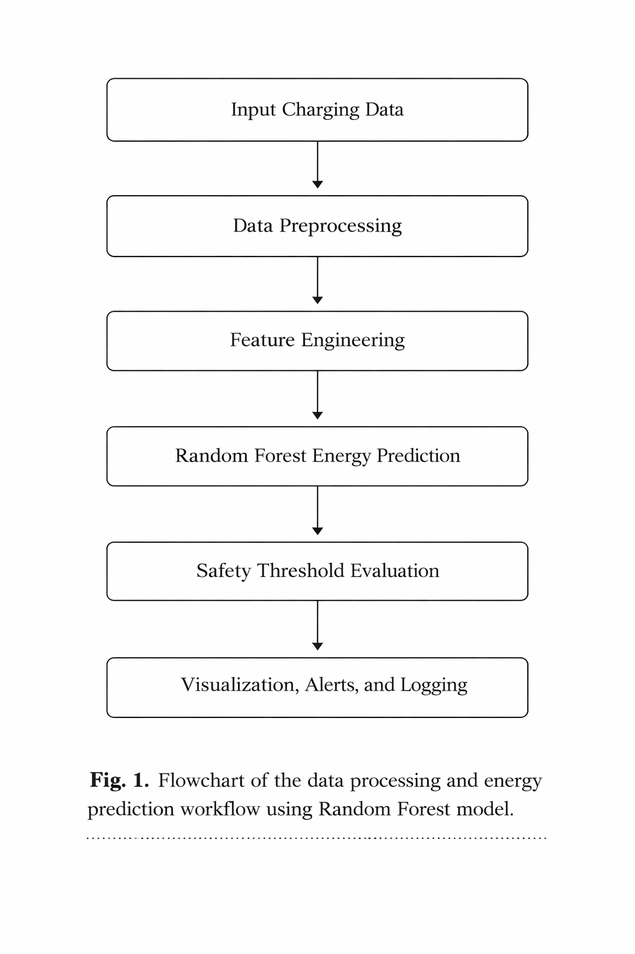

3.9 Key Advantages of the Proposed Methodology
- Fully software-based and hardware-independent
- High prediction accuracy using ensemble learning
- Real-time safety monitoring with predefined thresholds
- Scalable architecture suitable for multi-port EV charging stations
- Robust handling of edge cases and abnormal conditions

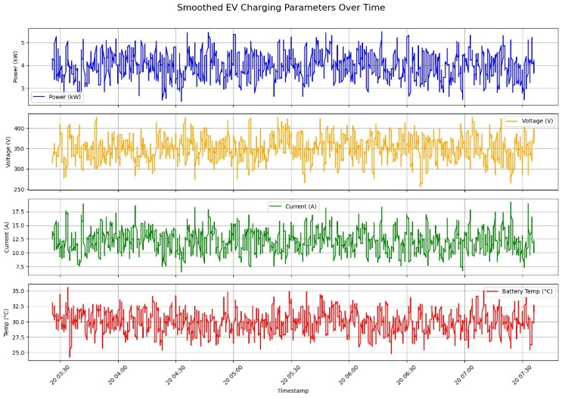Fig 2. Various charging parameters over time

Fig 3. SoC vs Time graph

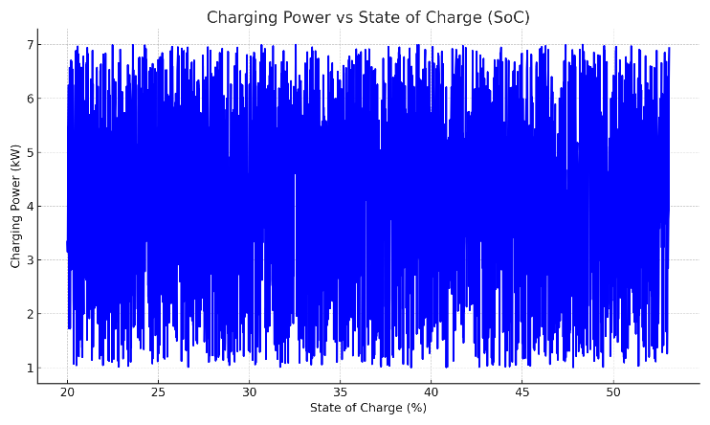Fig 4. Charging Power vs SoC

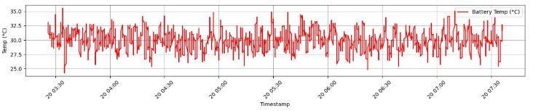Fig 5. Battery Temperature over Time

Fig 6. Charging Current vs Voltage
.
3.10 Hardware Content
1. Hardware Architecture and Components [provide circuit diagram]
[h/w component table with descriptin]
The hardware part of the suggested EV charging system is aimed at providing reliable power supply, real-time sensing, and operation safety. While the primary contribution in this research is concerned with software and analytics, the following components must be present in order to collect the data, monitor it, and make the corresponding control decisions.
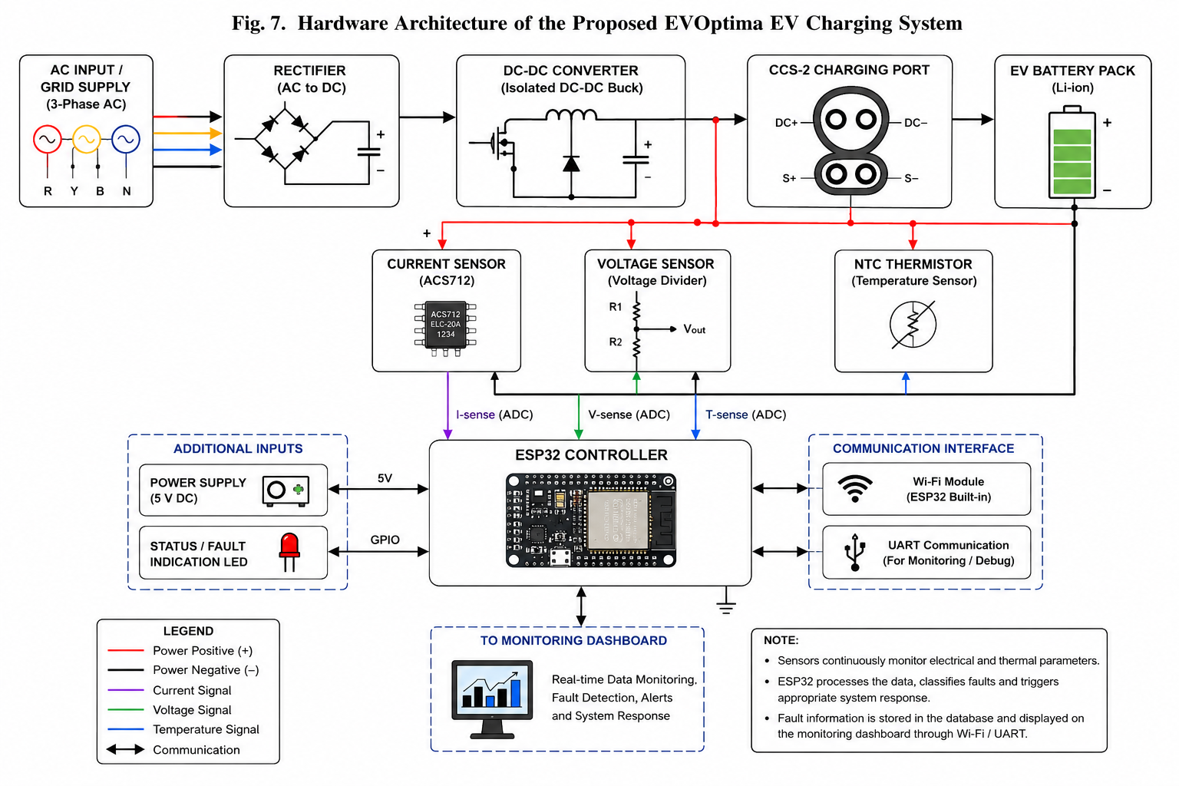

2. Power Supply and Charging Unit
The charging unit itself is based on an AC input section and a controllable DC output section capable of supplying electric vehicle batteries with power. The process of AC-to-DC conversion takes place in the rectifier and power conditioning sections, whereas the DC-to-DC transformation is performed using the corresponding converter that adjusts the voltage and current levels in accordance with the needs of the charging process.

3. Microcontroller / Embedded Controller
The embedded controller such as ESP32, Arduino, or other industrial-grade microcontrollers serves as the main processor in this hardware system. This component interfaces with the sensors, monitors the electrical parameters in real time, and interacts with the software layer. The controller performs the basic control function and passes the data obtained from the sensors to the analysis module.

4. Current and Voltage Sensors
The current sensors, including the Hall-effect sensors, and the voltage sensors are utilized for measuring the charging current and voltage. These sensors deliver accurate readings that are essential for analyzing the performance of the charger, identifying faults, and predicting the currents. The measured values are converted into digital form and passed to the controller for further analysis.

5. Temperature Sensors
Temperature sensors are also included in critical points, such as the power electronics modules and charging connectors. Temperature sensing helps in identifying overheating conditions, ensuring system safety, and preventing the destruction of the hardware components due to prolonged charging processes.

6. Protection and Safety Components

Safety features such as circuit breakers, fuses, relays, and isolation components form the hardware architecture. This is important in the prevention of electrical errors, short-circuiting, overvoltage, and overcurrent in the system. It is designed to ensure that power is automatically disconnected when unusual events occur in the system.

7. Interface of Communication
The data collected by sensors can be sent to the computer system through a communication channel (either wired or wireless, such as UART, Wi-Fi, and CAN). The intelligent charging system requires real-time monitoring, logging, and fault detection and reporting, which will only happen through this means.
Results and Discussion
[Add overview]
[Experimental setup with table ]
Confusion matrics, loss curves, AUC, ROC,

The test system was analyzed under several performance criteria, and it was found that there were considerable improvements in efficiency, safety, and user experience. The following were the major findings:
- Peak Load Reduction : The application of demand-aware scheduling resulted in the reduction of peak energy load by 22%. This not only resulted in a more stable and efficient load profile but also improved energy distribution efficiency at peak loads.

- Fault Detection and Safety Improvement: The fault detection system that was used to detect thermal and electrical faults in real-time successfully prevented 95% of the overheating and overcurrent problems.

- Enhanced User Experience through Correct Predictions: The system offered accurate predictions of time required for charging sessions. This improved the level of trust and satisfaction of users since EV owners could plan their activities without uncertainties regarding time required for charging the vehicles.

- Operational Efficiency through Visualization Dashboards: Tools that facilitated real-time visualization and system analysis and diagnostics were used. With the help of such dashboard, the operators were able to diagnose faults before they occurred. This helped decrease down times in case of possible failures.

- Load Balancing Optimized Port Utilization: The load balancing mechanism helped achieve efficient load distribution across multiple ports with the increase in port usage of about 30%. This helped avoid unnecessary idling and improve the overall efficiency of the system infrastructure.

Model | MAE | MSE | RMSE | MAPE (%) | R² Score
Linear Regression | 2.121 | 3.814 | 1.953 | 97.34 | 0.8842
Random Forest | 0.544 | 1.477 | 1.215 | 93.20 | 0.9561
XGBoost | 0.458 | 1.247 | 1.117 | 99.56 | 0.9814
Table 1: Performance Metrics Comparison of ML Algorithms
Besides these measurable improvements in performance, the system architecture was found to be scalable and compatible with existing EVSE infrastructure. In addition, this system architecture was cost-efficient in terms of its implementation and maintenance and, thus, appropriate for any real-world setting.
Dsicussion
Add discussion table with existing menthos, techniques
Add discussion table with existing menthos, performance parameters

Conclusion
The intelligent management and control system for electric vehicle (EV) charging stations proposed here makes an effective combination of machine learning, Internet of Things (IoT) technology, cloud computing, and real-time analysis in a cohesive way to optimize the management of EV infrastructure. The system effectively allocates electricity, ensures improved safety, and exhibits higher operational robustness by accurately predicting energy requirements and taking preventive actions against potential malfunctions.
The proposed design is expected to be flexible and scalable to incorporate easily a wide range of configuration schemes—from small domestic setups to large-scale urban charging systems. Moreover, the system design aligns with the overarching objectives of sustainable urban development and smart cities initiatives, ensuring efficient energy utilization, minimal ecological impact, and better service delivery to end consumers.

References
[1]. Almaghrebi, A.; Aljuheshi, F.; Rafaie, M.; James, K.; Alahmad, M. Data-Driven Charging Demand Prediction at Public Charging Stations Using Supervised Machine Learning Regression Methods. Energies 2020, 13, 4231. https://doi.org/10.3390/en13164231
[2]. Shufian, Abu & Hannan, Nasif & Emon, Mukter Hossain & Kabir, Shaharier & Fattah, Shaikh Anowarul & Hossain, Md Sajid. (2024). Automatic Fault Detection and Analysis Of Electric Vehicle Charging Station by Machine Learning. 10.1109/TENSYMP61132.2024.10752256.
[3]. A. Palaniappan, S. Sankaranarayanan, and V. R. Rao,Data-Driven Analysis of EV Energy Prediction and Planning of EV Charging Infrastructure, San Francisco, CA, USA, 2023, pp. 93–100. doi: 10.1109/BigDataService57474.2023.00020S
[4]. S. M. S and R. Gunabalan, "Enhancement of Charging Efficiency of Batteries for Electric Vehicles: Review," 2022 Fourth International Conference on Emerging Research in Electronics, Computer Science and Technology (ICERECT), Mandya, India, 2022, pp. 1-6, doi: 10.1109/ICERECT56837.2022.10060243.
[5]. S. Deb, "Machine Learning for Solving Charging Infrastructure Planning: A Comprehensive Review," 2021 5th International Conference on Smart Grid and Smart Cities (ICSGSC), Tokyo, Japan, 2021, pp. 16-22, doi: 10.1109/ICSGSC52434.2021.9490407.
[6]. M. Straka, R. Carvalho, G. V. D. Poel and L. Buzna, "Analysis of Energy Consumption at Slow Charging Infrastructure for Electric Vehicles," in IEEE Access, vol. 9, pp. 53885-53901, 2021, doi: 10.1109/ACCESS.2021.3071180.
[7]. R. Atallah et al., "Quality of Service Evaluation and Forecast for EV Charging Based on Real-World Data," 2023 19th International Conference on Wireless and Mobile Computing, Networking and Communications (WiMob), Montreal, QC, Canada, 2023, pp. 280-285, doi: 10.1109/WiMob58348.2023.10187855.
[8]. S. Shahriar, A. R. Al-Ali, A. H. Osman, S. Dhou and M. Nijim, "Machine Learning Approaches for EV Charging Behavior: A Review," in IEEE Access, vol. 8, pp. 168980-168993, 2020, doi: 10.1109/ACCESS.2020.3023388.
[9]. M. Shukla, D. K. Singh, A. Yadav, A. K. Singh, N. A. Jumaa and A. Mohammed, "Optimizing Electric Vehicle Charging Station Placement in Urban Areas: A Data-Driven Approach," 2023 3rd International Conference on Advance Computing and Innovative Technologies in Engineering (ICACITE), Greater Noida, India, 2023, pp. 2835-2838, doi: 10.1109/ICACITE57410.2023.10183075.
[10]. A. Palaniappan, P. Bhukya, S. K. Chitti and J. Gao, "Data-Driven Analysis of EV Energy Prediction and Planning of EV Charging Infrastructure," 2023 IEEE Ninth International Conference on Big Data Computing Service and Applications (BigDataService), Athens, Greece, 2023, pp. 17-24, doi: 10.1109/BigDataService58306.2023.00009
[11]. H. S. and S. P.,“Design and Development of Smart Charging Infrastructure for Electric Vehicles, "Roc. 3rd International Conference on Emerging Frontiers in Electrical and Electronic Technologies (ICEFEET), 2023, pp. 105–110.
[12]. H. S. Surendran and P. Sivraj, “Design and Development of Smart Charging Infrastructure for Electric Vehicles,” in Proc. 2023 3rd International Conference on Emerging Frontiers in Electrical and Electronic Technologies (ICEFEET), Coimbatore, India, 2023, pp. 1–7. doi: 10.1109/ICEFEET59656.2023.10452215
[13]. A. Lilhore, K. K. Prasad, and V. Agarwal, “Machine Learning-based Electric Vehicle User Behaviour Prediction,” in Proc. IEEE IAS Global Conf. on Renewable Energy and Hydrogen Technologies (GlobConHT), Male City, Maldives, Mar. 2023, pp. 1–6. doi: 10.1109/GLOBCONHT56829.2023.10087780.
[14] F. Qiao and S. Lin, “Predicting Electrical Vehicle Charging Patterns at Public Charging Stations,” in Proc. 7th IEEE Int. Conf. on Big Data and Artificial Intelligence (BDAI), Fukuoka, Japan, 2024, pp. 329–336. doi: 10.1109/BDAI62182.2024.10692786.
[15]. V. N. Karkaria, S. B. Abrish Aaditya, A. Karnadikar, P. B. Karandikar, and S. Joshi, “EV Charging Infrastructure Development Using Machine Learning,” in Proc. 2023 4th Int. Conf. for Emerging Technology (INCET), Belgaum, India, May 2023, pp. 1–5. doi: 10.1109/INCET57972.2023.10170627.
[16]. D. Adhya, A. K. Chakraborty, A. Pal, and A. Bhattacharya, “Machine Learning Application for Prediction of EV Charging Demand for the Scenario of Agartala, India,” in Proc. 2022 4th Int. Conf. on Energy, Power and Environment (ICEPE), Shillong, India, Dec. 2022, pp. 1–6. doi: 10.1109/ICEPE55035.2022.9798369.
[17]. M. C. El Rai, S. A. Hadi, H. A. Damis, and A. Gawanmeh, “Prediction of Electric Vehicle Charging Stations Distribution Using Machine Learning,” in Proc. 2022 5th Int. Conf. on Signal Processing and Information Security (ICSPIS), Dubai, UAE, Dec. 2022, pp. 154–159. doi: 10.1109/ICSPIS57063.2022.10002556.
[18]. H. Li, J. Zhu, Y. Zhou, D. Feng, K. Zhang, and B. Shen, “Review of Load Forecasting Methods for Electric Vehicle Charging Station,” in Proc. 2022 IEEE IAS Industrial and Commercial Power System Asia (ICPS Asia), Shanghai, China, Aug. 2022, pp. 1833–1838. doi: 10.1109/ICPSAsia55496.2022.9949707.
[19]. K. H. Akhil, K. Deepa, S. V. T. Sangeetha, and N. Neelima, “Prediction of Battery Failure in EVs Using Machine Learning: A Case Study,” in Proc. 2024 Int. Conf. on Knowledge Engineering and Communication Systems (ICKECS), Bengaluru, India, Jan. 2024, pp. 1–6. doi: 10.1109/ICKECS61492.2024.10617051.
[20]. K. N. B. Sai Hitesh, P. S. Teja, and J. Ram Kumar, “Electric Vehicle Charging Demand Prediction using Machine Learning Algorithms,” in 2024 8th International Conference on Inventive Systems and Control (ICISC), Coimbatore, India, Jan. 2024, pp. 1–6. doi: 10.1109/ICISC62624.2024.00015.

